**Lab – 14: How to add application credentials, or permissions to access web APIs in Azure.**

**Objective:** The objective of this lab is –

* To add application credentials, or permissions to access web APIs in the Azure portal.

Once your application has been registered with Azure AD, it may need to be updated to provide access to web APIs, be made available in other organizations, and more. Assume you have a web client application that needs to configure specific permissions to access a resource/API. In this lab, we are going to learn how to add application credentials, or permissions to access web APIs.

**Prerequisite:** EMS Enterprise Mobility + Security E5.

**Steps:**

1. Sign in to your Azure Portal, by using the link - **https://portal.azure.com/**. Enter your credentials and click Sign In.

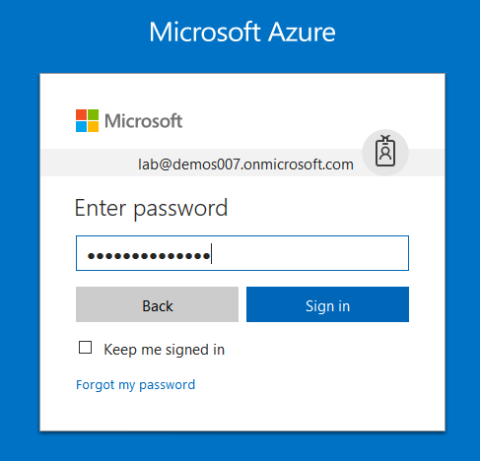

1. Microsoft Azure AD Dashboard will open.

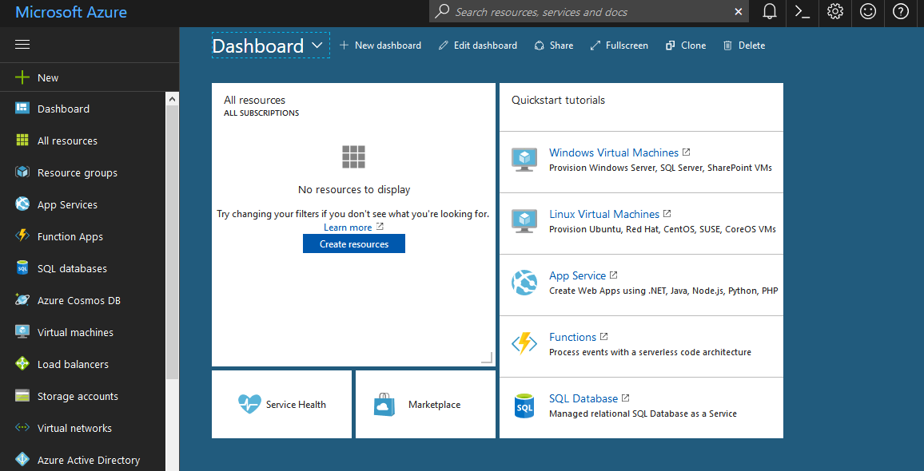

1. In the left-hand navigation pane, click the **Azure Active Directory** service, click **App registrations**.

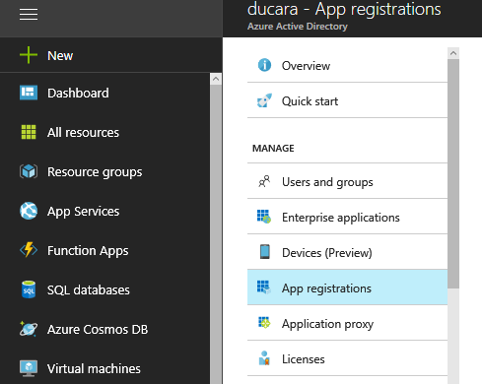

1. Then find and click the application you want to configure.

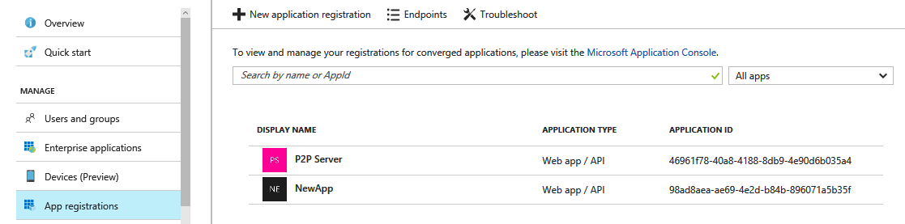

1. After clicking you are taken to the application's main registration page, which opens up the Settings page for the application.
2. To add a secret key for your web application's credentials, click the **Keys** section on the Settings page.

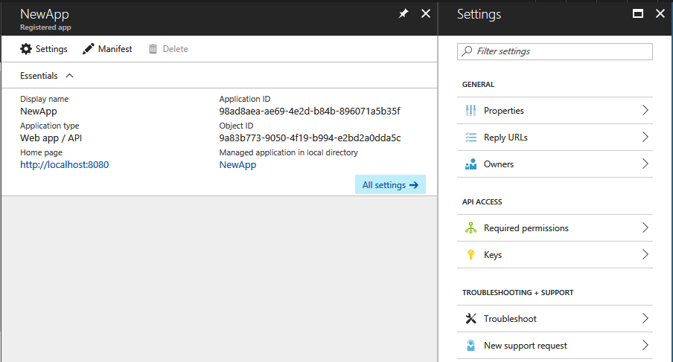

1. Add a **description** for your key. Select either a **one** or **two-year** duration.

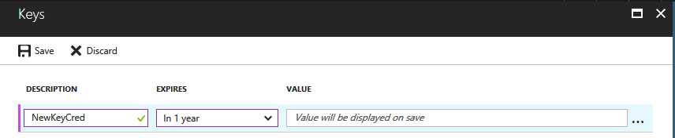

1. Then click **Save**. The right-most column will contain the key value, after you save the configuration changes. Be sure to copy the key for use in your client application code, as it is not accessible once you leave this page.

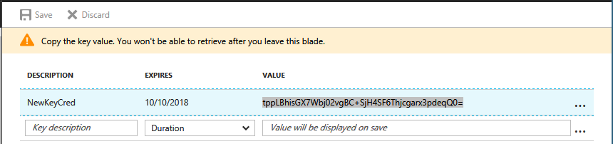

1. Now go back to the App settings window, to add permission(s) to access resource APIs from your client. For this, click the **Required Permissions** section on the Settings page.

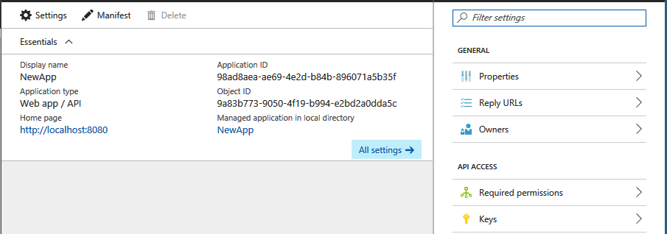

1. Click the **Add** button.

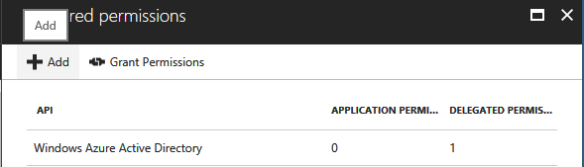

1. Click **Select an API** to select the type of resources you want to pick from.

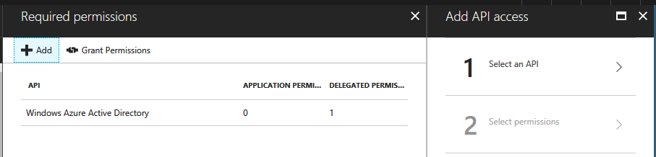

1. Browse through the list of available APIs or use the search box to select from the available resource applications in your directory that expose a web API. Click the resource you are interested in, then click **Select**.

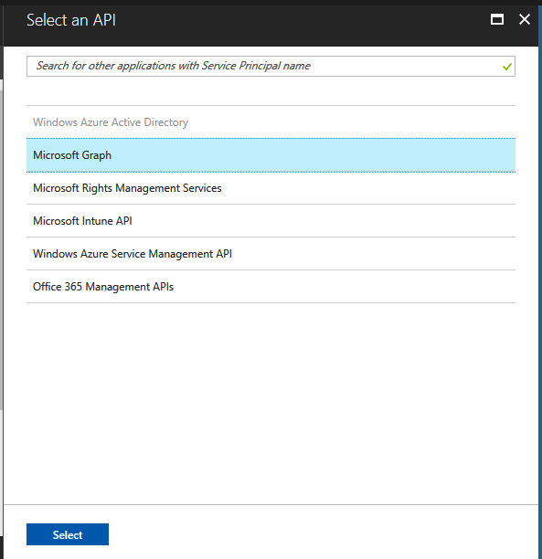

1. Now you're taken to the **Enable Access** page. Select the Application Permissions and/or Delegated Permissions your application needs when accessing the API. Like – Read Directory Data. When finished, click the **Select** button on **Enable Access** page.

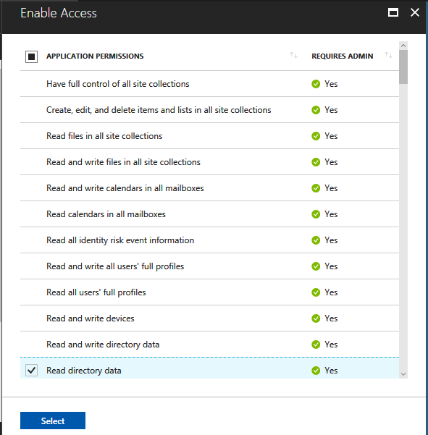

1. Then click the **Done** button on the **Add API access** page. You are returned to the Required permissions page, where the new resource is added to the list of APIs.

